***SQL DATABASES***  
  
**I have created 2 SQL data bases:**  
  
**1. Users**

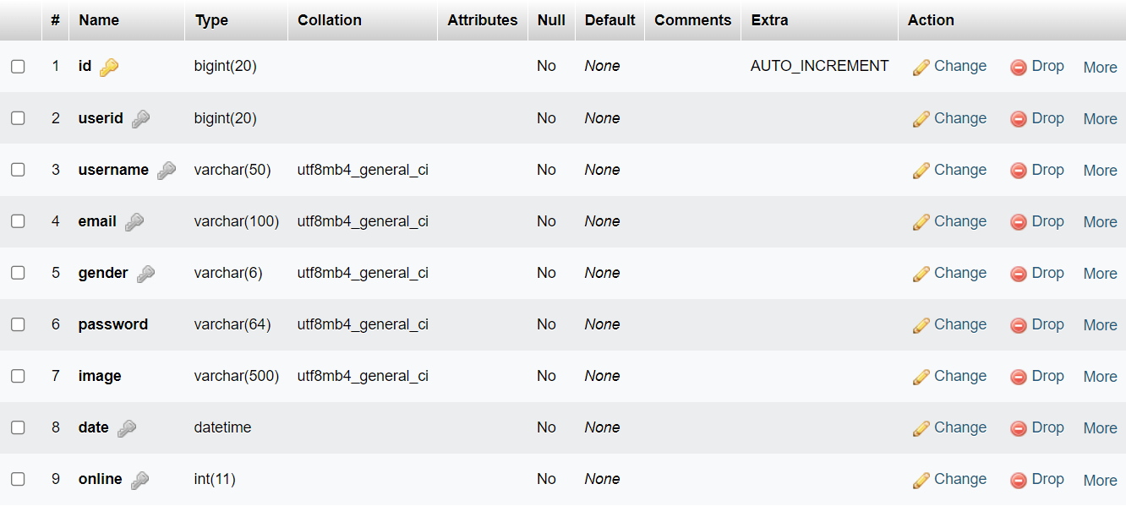

**2. Messages**

